Create and populate database and perform all data definition language (DDL) commands on your own considered database

-- Create tables
CREATE TABLE DEPARTMENT (
Dept_ID NUMBER PRIMARY KEY,
Dept_Name VARCHAR2(50) NOT NULL,
Location VARCHAR2(50)
);

CREATE TABLE EMPLOYEE (
Emp_ID NUMBER PRIMARY KEY,
Emp_Name VARCHAR2(50) NOT NULL,
Salary NUMBER CHECK (Salary > 0),
Dept_ID NUMBER REFERENCES DEPARTMENT(Dept_ID)
);

CREATE TABLE PROJECT (
Proj_ID NUMBER PRIMARY KEY,
Proj_Name VARCHAR2(50) UNIQUE,
Dept_ID NUMBER REFERENCES DEPARTMENT(Dept_ID)
);

-- Insert data
INSERT INTO DEPARTMENT VALUES (1, 'HR', 'Pune');
INSERT INTO DEPARTMENT VALUES (2, 'IT', 'Mumbai');

INSERT INTO EMPLOYEE VALUES (101, 'Aditya', 50000, 2);
INSERT INTO EMPLOYEE VALUES (102, 'Riya', 40000, 1);

INSERT INTO PROJECT VALUES (201, 'Website Dev', 2);
INSERT INTO PROJECT VALUES (202, 'Recruitment', 1);

-- DDL operations
ALTER TABLE EMPLOYEE ADD (Email VARCHAR2(50) DEFAULT 'notset@gmail.com');
ALTER TABLE EMPLOYEE MODIFY (Emp_Name VARCHAR2(100));
ALTER TABLE PROJECT DROP COLUMN Dept_ID;

-- Display data
SELECT * FROM DEPARTMENT;
SELECT * FROM EMPLOYEE;
SELECT * FROM PROJECT;

Perform all data Manipulation language (DML) commands on your own considered database

-- Create a table first
CREATE TABLE Employee (
Emp_ID NUMBER,
Emp_Name VARCHAR2(50),
Salary NUMBER,
City VARCHAR2(50)
);

-- INSERT: Add records into the table
INSERT INTO Employee VALUES (101, 'Aditya', 50000, 'Pune');
INSERT INTO Employee VALUES (102, 'Riya', 45000, 'Mumbai');
INSERT INTO Employee VALUES (103, 'Rahul', 40000, 'Delhi');

-- SELECT: View all data
SELECT * FROM Employee;

-- UPDATE: Modify data in the table
UPDATE Employee SET Salary = 55000 WHERE Emp_ID = 101;

-- DELETE: Remove one record
DELETE FROM Employee WHERE Emp_ID = 103;

-- SELECT again to see changes
SELECT * FROM Employee;

Apply Integrity Constraints (NOT NULL, CHECK, UNIQUE, DEFAULT) for your database system

CREATE TABLE Student (
RollNo NUMBER UNIQUE, -- UNIQUE
Name VARCHAR2(50) NOT NULL, -- NOT NULL
Age NUMBER CHECK (Age >= 18), -- CHECK
City VARCHAR2(50) DEFAULT 'Pune'-- DEFAULT
);

INSERT INTO Student (RollNo, Name, Age) VALUES (1, 'Aditya', 19);
INSERT INTO Student (RollNo, Name, Age, City) VALUES (2, 'Riya', 20, 'Mumbai');

SELECT * FROM Student;

Apply foreign key relationship and primary key constraints to relations in your database system.
-- Create DEPARTMENT table (Parent table)
CREATE TABLE Department (
Dept_ID NUMBER PRIMARY KEY,
Dept_Name VARCHAR2(50)
);

-- Create EMPLOYEE table (Child table)
CREATE TABLE Employee (
Emp_ID NUMBER PRIMARY KEY,
Emp_Name VARCHAR2(50),
Dept_ID NUMBER,
FOREIGN KEY (Dept_ID) REFERENCES Department(Dept_ID)
);

-- Insert data
INSERT INTO Department VALUES (1, 'HR');
INSERT INTO Department VALUES (2, 'IT');

INSERT INTO Employee VALUES (101, 'Aditya', 2);
INSERT INTO Employee VALUES (102, 'Riya', 1);

-- Display data
SELECT * FROM Department;
SELECT * FROM Employee;

Implement and execute Nested queries for your own database system
-- Create table Department
CREATE TABLE Department (
Dept_ID NUMBER PRIMARY KEY,
Dept_Name VARCHAR2(50)
);

-- Create table Employee
CREATE TABLE Employee (
Emp_ID NUMBER PRIMARY KEY,
Emp_Name VARCHAR2(50),
Salary NUMBER,
Dept_ID NUMBER REFERENCES Department(Dept_ID)
);

-- Insert data
INSERT INTO Department VALUES (1, 'HR');
INSERT INTO Department VALUES (2, 'IT');

INSERT INTO Employee VALUES (101, 'Aditya', 50000, 2);
INSERT INTO Employee VALUES (102, 'Riya', 40000, 1);
INSERT INTO Employee VALUES (103, 'Rahul', 60000, 2);

-- 1️⃣ Nested query: find employees who earn more than average salary
SELECT Emp_Name, Salary
FROM Employee
WHERE Salary > (SELECT AVG(Salary) FROM Employee);

-- 2️⃣ Nested query: find employees working in 'IT' department
SELECT Emp_Name
FROM Employee
WHERE Dept_ID = (
SELECT Dept_ID FROM Department WHERE Dept_Name = 'IT'
);

Implement and execute Nested queries for your own database system
-- Create table Department
CREATE TABLE Department (
Dept_ID NUMBER PRIMARY KEY,
Dept_Name VARCHAR2(50)
);

-- Create table Employee
CREATE TABLE Employee (
Emp_ID NUMBER PRIMARY KEY,
Emp_Name VARCHAR2(50),
Salary NUMBER,
Dept_ID NUMBER REFERENCES Department(Dept_ID)
);

-- Insert data
INSERT INTO Department VALUES (1, 'HR');
INSERT INTO Department VALUES (2, 'IT');

INSERT INTO Employee VALUES (101, 'Aditya', 50000, 2);
INSERT INTO Employee VALUES (102, 'Riya', 40000, 1);
INSERT INTO Employee VALUES (103, 'Rahul', 60000, 2);

-- 1️⃣ Nested query: find employees who earn more than average salary
SELECT Emp_Name, Salary
FROM Employee
WHERE Salary > (SELECT AVG(Salary) FROM Employee);

-- 2️⃣ Nested query: find employees working in 'IT' department
SELECT Emp_Name
FROM Employee
WHERE Dept_ID = (
SELECT Dept_ID FROM Department WHERE Dept_Name = 'IT'
);

Perform and Implement inner Join operations on your database tables
-- Create Department table
CREATE TABLE Department (
Dept_ID NUMBER PRIMARY KEY,
Dept_Name VARCHAR2(50)
);

-- Create Employee table
CREATE TABLE Employee (
Emp_ID NUMBER PRIMARY KEY,
Emp_Name VARCHAR2(50),
Dept_ID NUMBER REFERENCES Department(Dept_ID)
);

-- Insert data
INSERT INTO Department VALUES (1, 'HR');
INSERT INTO Department VALUES (2, 'IT');
INSERT INTO Department VALUES (3, 'Finance');

INSERT INTO Employee VALUES (101, 'Aditya', 2);
INSERT INTO Employee VALUES (102, 'Riya', 1);
INSERT INTO Employee VALUES (103, 'Rahul', 2);

-- INNER JOIN: shows only matching records
SELECT Employee.Emp_ID, Employee.Emp_Name, Department.Dept_Name
FROM Employee
INNER JOIN Department
ON Employee.Dept_ID = Department.Dept_ID;

Perform and Implement outer Join operations on your database tables
-- Create Department table
CREATE TABLE Department (
Dept_ID NUMBER PRIMARY KEY,
Dept_Name VARCHAR2(50)
);

-- Create Employee table
CREATE TABLE Employee (
Emp_ID NUMBER PRIMARY KEY,
Emp_Name VARCHAR2(50),
Dept_ID NUMBER
);

-- Insert data
INSERT INTO Department VALUES (1, 'HR');
INSERT INTO Department VALUES (2, 'IT');
INSERT INTO Department VALUES (3, 'Finance');

INSERT INTO Employee VALUES (101, 'Aditya', 2);
INSERT INTO Employee VALUES (102, 'Riya', 1);
-- Note: No employee in Finance department

-- LEFT OUTER JOIN
SELECT e.Emp_Name, d.Dept_Name
FROM Employee e
LEFT OUTER JOIN Department d
ON e.Dept_ID = d.Dept_ID;

-- RIGHT OUTER JOIN
SELECT e.Emp_Name, d.Dept_Name
FROM Employee e
RIGHT OUTER JOIN Department d
ON e.Dept_ID = d.Dept_ID;

Perform and Implement outer Join operations on your database tables
-- Create tables
CREATE TABLE Department (
Dept_ID NUMBER,
Dept_Name VARCHAR2(50)
);

CREATE TABLE Employee (
Emp_ID NUMBER,
Emp_Name VARCHAR2(50),
Dept_ID NUMBER
);

-- Insert data
INSERT INTO Department VALUES (1, 'HR');
INSERT INTO Department VALUES (2, 'IT');
INSERT INTO Department VALUES (3, 'Finance');

INSERT INTO Employee VALUES (101, 'Aditya', 2);
INSERT INTO Employee VALUES (102, 'Riya', 1);

-- LEFT OUTER JOIN
SELECT Emp_Name, Dept_Name
FROM Employee
LEFT OUTER JOIN Department
ON Employee.Dept_ID = Department.Dept_ID;

-- RIGHT OUTER JOIN
SELECT Emp_Name, Dept_Name
FROM Employee
RIGHT OUTER JOIN Department
ON Employee.Dept_ID = Department.Dept_ID;

Implement views and perform various operations on your database tables
-- Create table
CREATE TABLE Employee (
Emp_ID NUMBER,
Emp_Name VARCHAR2(50),
Salary NUMBER,
Dept VARCHAR2(50)
);

-- Insert data
INSERT INTO Employee VALUES (101, 'Aditya', 50000, 'IT');
INSERT INTO Employee VALUES (102, 'Riya', 45000, 'HR');
INSERT INTO Employee VALUES (103, 'Rahul', 60000, 'IT');

-- Create a VIEW
CREATE VIEW IT_Employees AS
SELECT Emp_Name, Salary
FROM Employee
WHERE Dept = 'IT';

-- View data from the view
SELECT * FROM IT_Employees;

-- Update through view
UPDATE IT_Employees SET Salary = 65000 WHERE Emp_Name = 'Aditya';

-- Drop the view
DROP VIEW IT_Employees;

Implement Trigger on your database tables
-- Create main table
CREATE TABLE Employee (
Emp_ID NUMBER,
Emp_Name VARCHAR2(50),
Salary NUMBER
);

-- Create log table to record changes
CREATE TABLE Emp_Log (
Emp_ID NUMBER,
Action VARCHAR2(20),
Action_Time DATE
);

-- Create Trigger
CREATE OR REPLACE TRIGGER emp_after_insert
AFTER INSERT ON Employee
FOR EACH ROW
BEGIN
INSERT INTO Emp_Log VALUES (:NEW.Emp_ID, 'Inserted', SYSDATE);
END;
/

-- Insert data into main table
INSERT INTO Employee VALUES (101, 'Aditya', 50000);
INSERT INTO Employee VALUES (102, 'Riya', 45000);

-- View both tables
SELECT * FROM Employee;
SELECT * FROM Emp_Log;

Create DEPARTMENT Table with columns Department_Id, Name,Location_ID. Constraints on DEPARTMENT table, Department_Id Primary Key,Location_Id references LOCATION table

-- Create LOCATION table (parent table)
CREATE TABLE Location (
Location_ID NUMBER PRIMARY KEY,
City VARCHAR2(50)
);

-- Create DEPARTMENT table (child table)
CREATE TABLE Department (
Department_ID NUMBER PRIMARY KEY,
Name VARCHAR2(50),
Location_ID NUMBER REFERENCES Location(Location_ID)
);

-- Insert sample data
INSERT INTO Location VALUES (1, 'Pune');
INSERT INTO Location VALUES (2, 'Mumbai');

INSERT INTO Department VALUES (101, 'HR', 1);
INSERT INTO Department VALUES (102, 'IT', 2);

-- View data
SELECT * FROM Location;
SELECT * FROM Department;
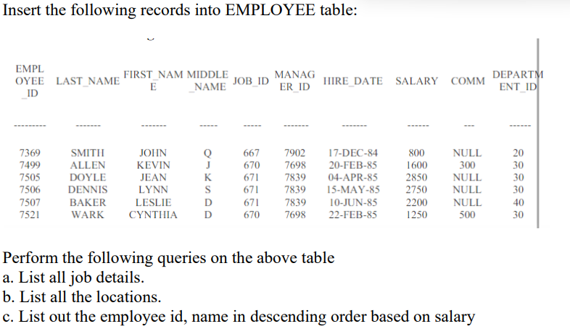

-- Create EMPLOYEE table
CREATE TABLE Employee (
Employee_ID NUMBER,
Last_Name VARCHAR2(20),
First_Name VARCHAR2(20),
Middle_Name VARCHAR2(20),
Job_ID NUMBER,
Manager_ID NUMBER,
Hire_Date DATE,
Salary NUMBER,
Comm NUMBER,
Department_ID NUMBER
);

-- Insert records
INSERT INTO Employee VALUES (7369, 'SMITH', 'JOHN', 'Q', 667, 7902, TO_DATE('17-DEC-84','DD-MON-YY'), 800, NULL, 20);
INSERT INTO Employee VALUES (7499, 'ALLEN', 'KEVIN', 'J', 670, 7698, TO_DATE('20-FEB-85','DD-MON-YY'), 1600, 300, 30);
INSERT INTO Employee VALUES (7505, 'DOYLE', 'JEAN', 'K', 671, 7839, TO_DATE('04-APR-85','DD-MON-YY'), 2850, NULL, 30);
INSERT INTO Employee VALUES (7506, 'DENNIS', 'LYNN', 'S', 671, 7839, TO_DATE('15-MAY-85','DD-MON-YY'), 2750, NULL, 30);
INSERT INTO Employee VALUES (7507, 'BAKER', 'LESLIE', 'D', 671, 7839, TO_DATE('10-JUN-85','DD-MON-YY'), 2200, NULL, 40);
INSERT INTO Employee VALUES (7521, 'WARK', 'CYNTHIA', 'D', 670, 7698, TO_DATE('22-FEB-85','DD-MON-YY'), 1250, 500, 30);

-- View table
SELECT * FROM Employee;

-- (a) List all job details
SELECT DISTINCT Job_ID FROM Employee;

-- (b) List all the locations (Department IDs used as location here)
SELECT DISTINCT Department_ID FROM Employee;

-- (c) List employee id and name in descending order based on salary
SELECT Employee_ID, First_Name, Last_Name, Salary
FROM Employee
ORDER BY Salary DESC;

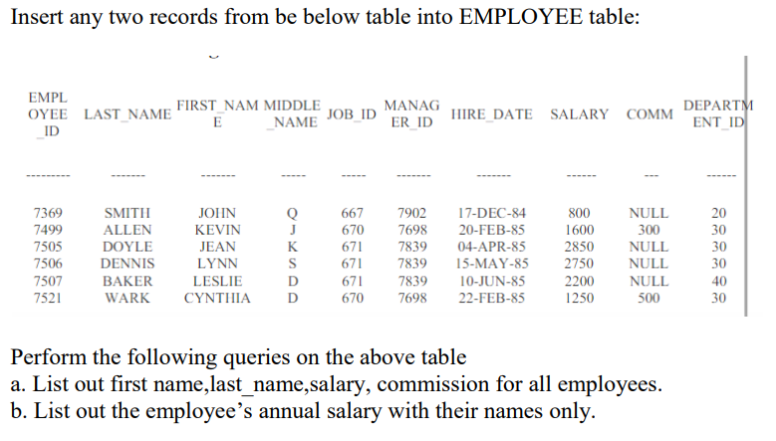

-- Create Employee Table
CREATE TABLE Employee (
Employee_ID NUMBER PRIMARY KEY,
Last_Name VARCHAR2(20),
First_Name VARCHAR2(20),
Middle_Name VARCHAR2(20),
Job_ID NUMBER,
Manager_ID NUMBER,
Hire_Date DATE,
Salary NUMBER,
Comm NUMBER,
Department_ID NUMBER
);

-- Insert sample employee data
INSERT INTO Employee VALUES (7369, 'SMITH', 'JOHN', 'Q', 667, 7902, TO_DATE('17-DEC-84','DD-MON-YY'), 800, NULL, 20);
INSERT INTO Employee VALUES (7499, 'ALLEN', 'KEVIN', 'J', 670, 7698, TO_DATE('20-FEB-85','DD-MON-YY'), 1600, 300, 30);
INSERT INTO Employee VALUES (7521, 'WARD', 'ALEX', 'T', 671, 7698, TO_DATE('22-FEB-85','DD-MON-YY'), 1250, 500, 30);
INSERT INTO Employee VALUES (7566, 'JONES', 'MARTIN', 'L', 672, 7839, TO_DATE('02-APR-85','DD-MON-YY'), 2975, NULL, 20);
INSERT INTO Employee VALUES (7654, 'MARTIN', 'JAMES', 'B', 673, 7698, TO_DATE('28-SEP-85','DD-MON-YY'), 1250, 1400, 30);

COMMIT;

-- a) List first name, last name, salary, and commission for all employees
SELECT First_Name, Last_Name, Salary, Comm
FROM Employee;

-- b) List employee’s annual salary with their names
SELECT First_Name, Last_Name, (Salary * 12) AS Annual_Salary
FROM Employee;

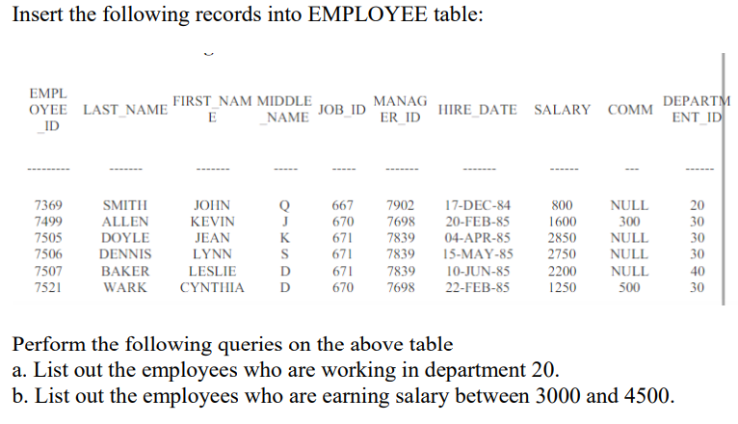

-- Create the EMPLOYEE table
CREATE TABLE Employee (
Employee_ID NUMBER PRIMARY KEY,
Last_Name VARCHAR2(20),
First_Name VARCHAR2(20),
Middle_Name VARCHAR2(20),
Job_ID NUMBER,
Manager_ID NUMBER,
Hire_Date DATE,
Salary NUMBER,
Comm NUMBER,
Department_ID NUMBER
);

-- Insert given records
INSERT INTO Employee VALUES (7369, 'SMITH', 'JOHN', 'Q', 667, 7902, TO_DATE('17-DEC-84','DD-MON-YY'), 800, NULL, 20);
INSERT INTO Employee VALUES (7499, 'ALLEN', 'KEVIN', 'J', 670, 7698, TO_DATE('20-FEB-85','DD-MON-YY'), 1600, 300, 30);
INSERT INTO Employee VALUES (7505, 'DOYLE', 'JEAN', 'K', 671, 7839, TO_DATE('04-APR-85','DD-MON-YY'), 2850, NULL, 30);
INSERT INTO Employee VALUES (7506, 'DENNIS', 'LYNN', 'S', 671, 7839, TO_DATE('15-MAY-85','DD-MON-YY'), 2750, NULL, 30);
INSERT INTO Employee VALUES (7507, 'BAKER', 'LESLIE', 'D', 671, 7839, TO_DATE('10-JUN-85','DD-MON-YY'), 2200, NULL, 40);
INSERT INTO Employee VALUES (7521, 'WARK', 'CYNTHIIA', 'D', 670, 7698, TO_DATE('22-FEB-85','DD-MON-YY'), 1250, 500, 30);

COMMIT;

-- a) Employees working in department 20
SELECT First_Name, Last_Name, Department_ID
FROM Employee
WHERE Department_ID = 20;

-- b) Employees earning salary between 3000 and 4500
SELECT First_Name, Last_Name, Salary
FROM Employee
WHERE Salary BETWEEN 3000 AND 4500;

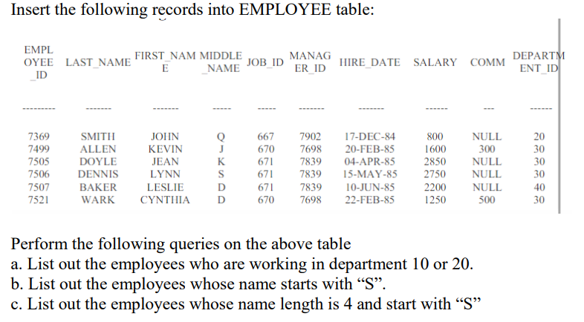

-- Create EMPLOYEE table
CREATE TABLE Employee (
Employee_ID NUMBER PRIMARY KEY,
Last_Name VARCHAR2(20),
First_Name VARCHAR2(20),
Middle_Name VARCHAR2(20),
Job_ID NUMBER,
Manager_ID NUMBER,
Hire_Date DATE,
Salary NUMBER,
Comm NUMBER,
Department_ID NUMBER
);

-- Insert given records
INSERT INTO Employee VALUES (7369, 'SMITH', 'JOHN', 'Q', 667, 7902, TO_DATE('17-DEC-84','DD-MON-YY'), 800, NULL, 20);
INSERT INTO Employee VALUES (7499, 'ALLEN', 'KEVIN', 'J', 670, 7698, TO_DATE('20-FEB-85','DD-MON-YY'), 1600, 300, 30);
INSERT INTO Employee VALUES (7505, 'DOYLE', 'JEAN', 'K', 671, 7839, TO_DATE('04-APR-85','DD-MON-YY'), 2850, NULL, 30);
INSERT INTO Employee VALUES (7506, 'DENNIS', 'LYNN', 'S', 671, 7839, TO_DATE('15-MAY-85','DD-MON-YY'), 2750, NULL, 30);
INSERT INTO Employee VALUES (7507, 'BAKER', 'LESLIE', 'D', 671, 7839, TO_DATE('10-JUN-85','DD-MON-YY'), 2200, NULL, 40);
INSERT INTO Employee VALUES (7521, 'WARK', 'CYNTHIIA', 'D', 670, 7698, TO_DATE('22-FEB-85','DD-MON-YY'), 1250, 500, 30);

COMMIT;

-- a) Employees who are working in department 10 or 20
SELECT First_Name, Last_Name, Department_ID
FROM Employee
WHERE Department_ID IN (10, 20);

-- b) Employees whose name starts with 'S'
SELECT First_Name, Last_Name
FROM Employee
WHERE Last_Name LIKE 'S%';

-- c) Employees whose name length is 4 and starts with 'S'
SELECT First_Name, Last_Name
FROM Employee
WHERE Last_Name LIKE 'S%' AND LENGTH(Last_Name) = 4;

